Electronic label image production

In the test phase, you can manually create an image of the electronic label. The method of making it is as follows:

1. Make BMP format pictures

2. Convert BMP format images to bin format.

3. Converted BIN format picture to a JSON message.

# Make BMP format pictures

This screen does not support gray scale. When making pictures, you need to make a pure black and white picture with 296*128 resolutions.

Example:

testpass.bmp.

The following uses the windows drawing tool as an example:

1, Windows attachment menu = "painting

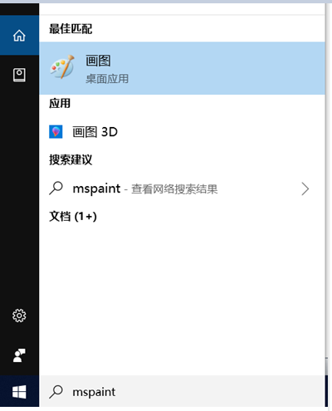

2. set the resolution to 296*128

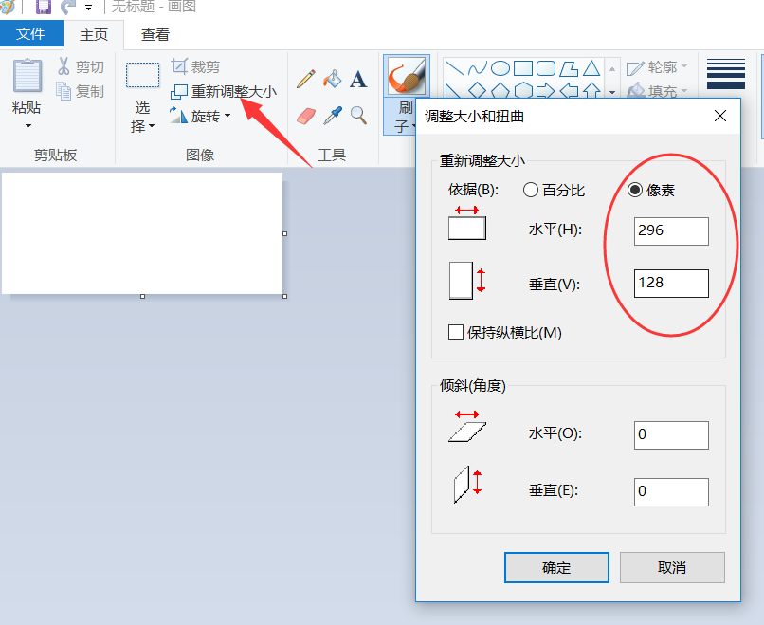

3. You can add text on the picture.

4. Save, please select the single color bitmap to save.

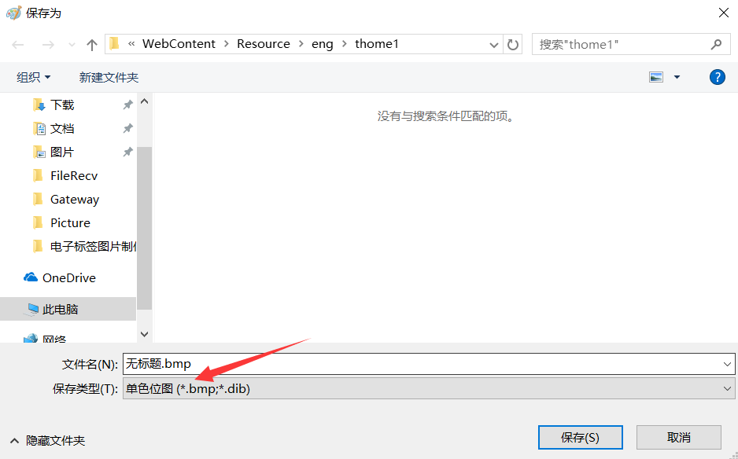

# Convert BMP format images to bin format

 Through the third-party software image2lcd software, there is a compression package (under the picture stencil tool directory), which contains the license; otherwise the created picture will have a watermark.

The parameter setting interface is shown in Figure 2:

1. Open image2lcd and load the image that needs to be modulo.

2, the output data type: select "binary BIN";

3, scanning method: select "vertical scanning";

4, output gray: select "monochrome";

5, the maximum width and height: select "296", "128", after selection, you need to click the arrow below to confirm;



6. Check "Scan from right to left";

7, positive display (black on white), then "color reversal" check; negative display (black on white) does not need to check.

8. Click "Save" to save the converted array to the extension "bin file;

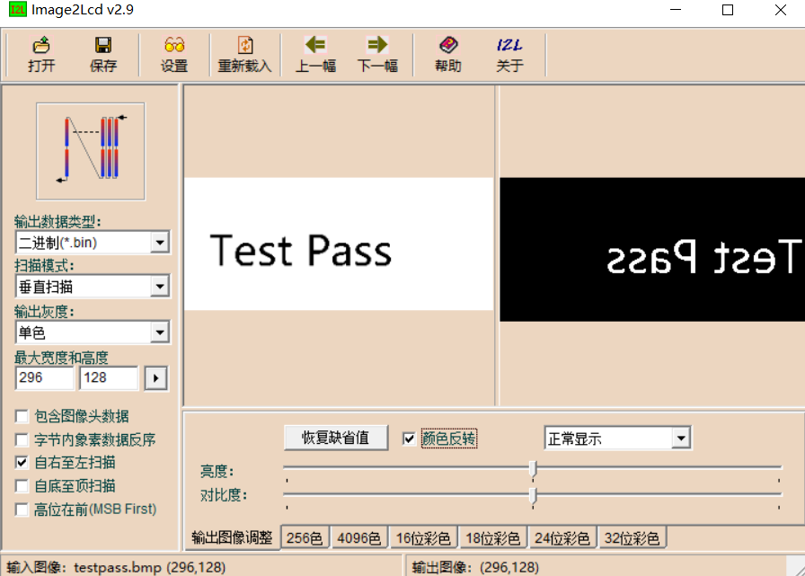

# Converted BIN format picture to a JSON message

1. Please put the BIN files generated in the previous step and Bin2Json.exe in the same directory.

2, run the Bin2Json.exe tool, the parameters you need to enter are as follows:

a) BIN file name.

b) The password of the tag, the default is 8 0

c) The mac address of the device can be viewed through the gateway status monitoring to the 12-bit mac address.

d) The ID of the picture, you can enter a number arbitrarily, this is equivalent to the number of this picture.

e) Whether compression, for tags with version number 1, compression is not supported. The version number is 2 and subsequent tags support the image compression algorithm.

➢ How to identify the version of the label: Report the status of the label from the status of the label. See Section 4.2 of the Electronic Label Integration Development Guide.

➢ For simple images, it is recommended to use an ASCII text-based compression algorithm and then post the image. Compressing the image and then sending it will greatly reduce the refresh time.

After the carriage return, you will be prompted to write the JSON file successfully. You can see that a testpic.bin.json file is generated in the same directory, which is the image update message.

Bin2Json.exe is based on Visual Studio 2012 written in C language. The source code can be downloaded at:

<https://github.com/kkmhogen/ESLBin2Json.git>

